DOCUMENT 01 — Product Strategy & Lifetime User Journey
Visionary Internal · v1.0 · Internal only — never public.

Visionary is India's first Human AGI for Learning & Building. Not a chatbot, not a
content library, not a course platform. It is an intelligence that understands WHO you
are, what you're trying to achieve, what you already know, where you struggle, and what
you should do next — for a lifetime, in your own language.

1. The One Product Truth (the moat)
The single most powerful feature is "THINGS I REMEMBER ABOUT YOU."
- The AGI must feel like a teacher who paid attention, never like AI.
- Specificity = humanity. "You study Physics most often. Your average confidence is 56%.
You've mastered 14 topics." beats any generic praise.
- Never "Great job!" — always a specific, earned observation.
- This memory is the lock-in: a student who sees new true insights weekly feels the
product is alive and cannot leave.
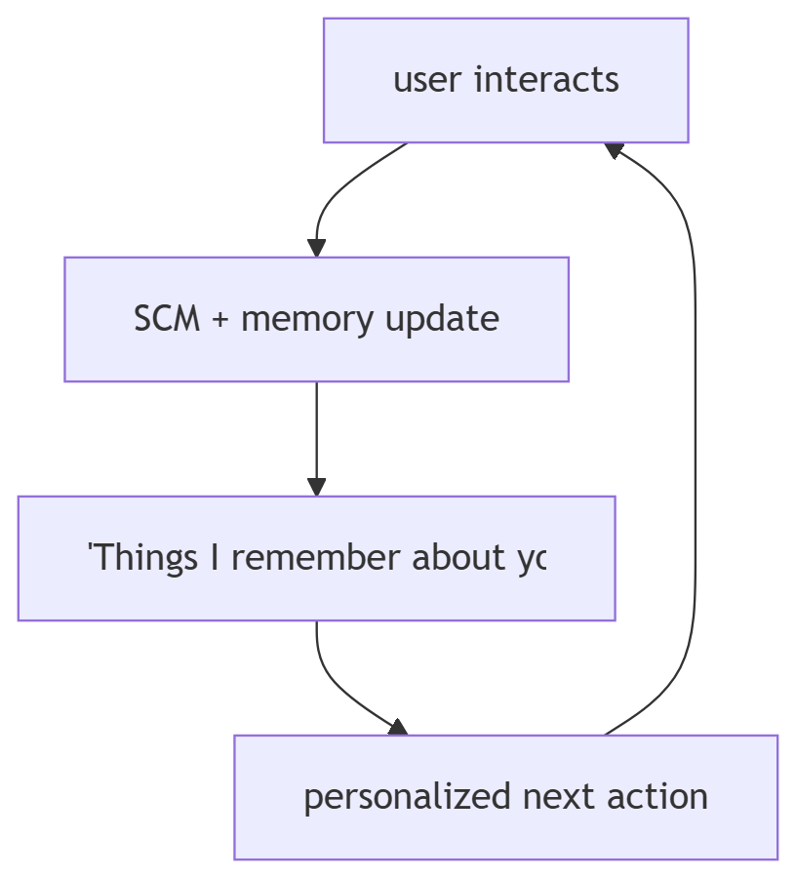

2. The 4-App Framework (permanent)
Learn · Ask · Practice · Build. Never changes; stakeholders change intent, not the frame.

3. Lifetime journey (age 15 → 45)
One account, one memory, five life stages. The AGI grows with the person.

4. Seven user segments
K12 student · competitive aspirant · higher-ed student · teacher · parent · working
professional · organization/institution.

5. Critical fixes (non-negotiable UI doctrine)
1. Replace search bar with "Ask me anything, Ecoh…" (AGI-first, not search-first).
2. Never show 0 as a first number (new topic → "let's discover your level").
3. Subject-specific visual identity (Math ≠ Physics ≠ English illustration).
4. Language as visible identity ("Ecoh · हिन्दी" badge), not a hidden setting.
5. AGI specificity in every message (reference the user's own state first).
6. Real project thumbnails in Build (not placeholder boxes).

6. AGI voice rules
Warm · specific · patient. Speaks FIRST each session. References something true about the
user before anything general. No corporate/AI jargon in user-facing copy.

7. Revenue (summary; full model in Doc 06)
Free · Student ₹199 · Competitive ₹499 · Professional ₹399 · Family ₹599 ·
School ₹5L/yr · Corporate custom · marketplace commission.

OKF
KF1: first-session "it knows me" moment ≤60s. KF2: weekly memory card shows ≥3 TRUE new
observations. KF3: 0 generic-praise strings ship. KF4: language badge visible on every
screen. KF5: never a bare 0 to a new user.

